**Lab 2 – Cloud Security trends**

* Name : Xihai Ren
* Course: CST8921 010
* Professor : Ragini Madaan
* Date : 2025/05/19

**Securing Cloud Infrastructure for a Canadian FinTech Startup**

**Background:**  
You are a **Cloud Security Analyst** at *TrueNorth Pay*, a growing FinTech startup based in Toronto. The company has just moved its infrastructure to the cloud (Azure) to scale faster and cut costs. However, as a financial services provider, they must comply with strict data residency laws and cybersecurity regulations.

Your manager has tasked you with **designing and implementing a secure cloud storage and networking setup** to meet the following requirements:

**Business Requirements:**

1. **Data Residency Compliance**
   * All resources must be deployed only in **Canada Central** to comply with data residency requirements.
2. **Private Data Access Only**
   * Sensitive data, such as customer transaction records stored in Azure Files, must **never be accessible from the public internet**.
3. **Controlled Developer Access**
   * Developers working remotely should be able to access the file share through secure **Remote Desktop** into a VM in a private network.
4. **Security Best Practices**
   * Only specific subnets and VMs should be able to access the storage.
   * Public VMs should be denied access to sensitive storage even if credentials are leaked.

**Objective:**

Build and test a secure cloud network and storage configuration that meets the above requirements. Specifically, you will:

* Set up region-based policies
* Create virtual networks and subnets
* Configure storage endpoints
* Secure access using network security groups
* Verify and document both allowed and denied access attempts

**Lab Activity Overview:**

**Cloud Policy:**

1. Create an Allowed Locations policy that ensures resource are only created in a specific region.

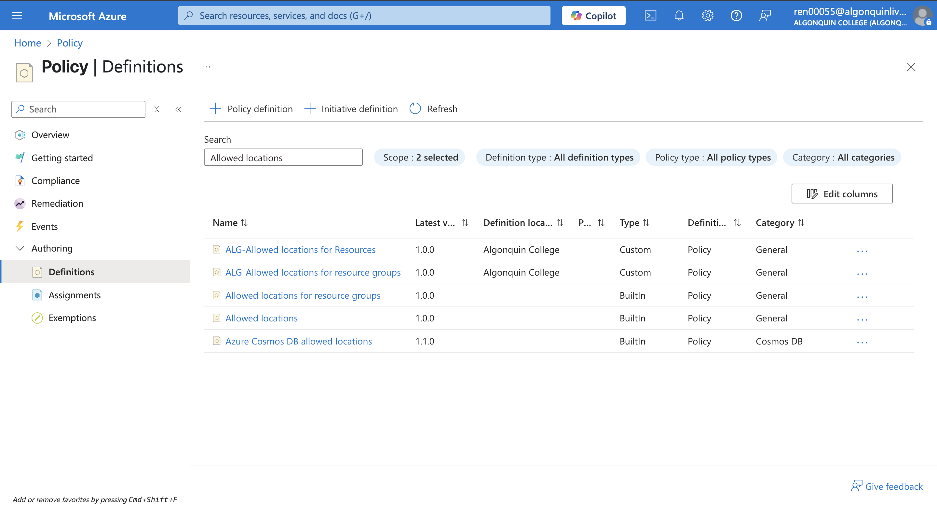

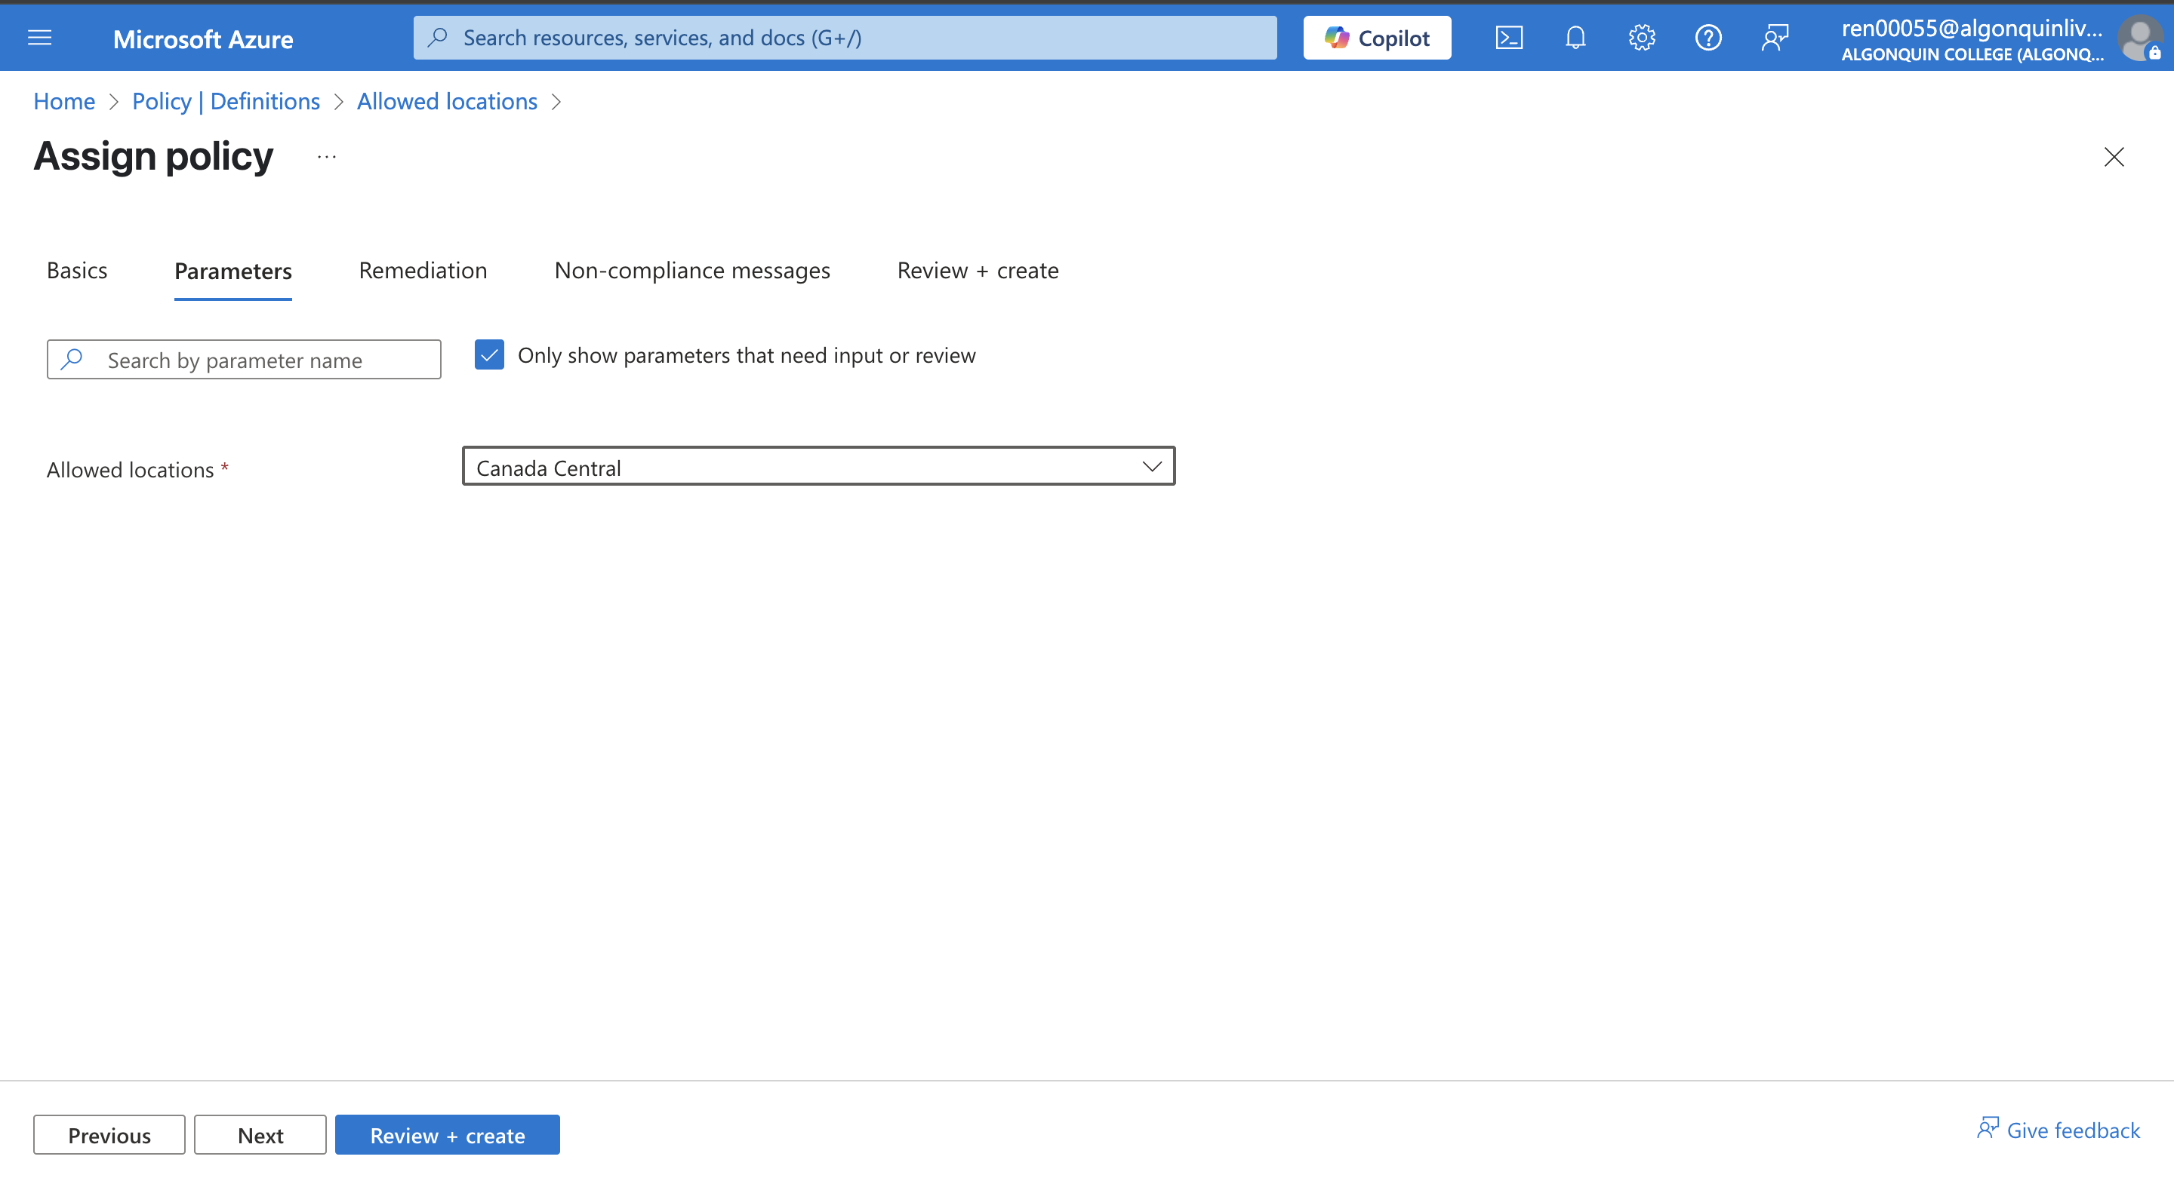

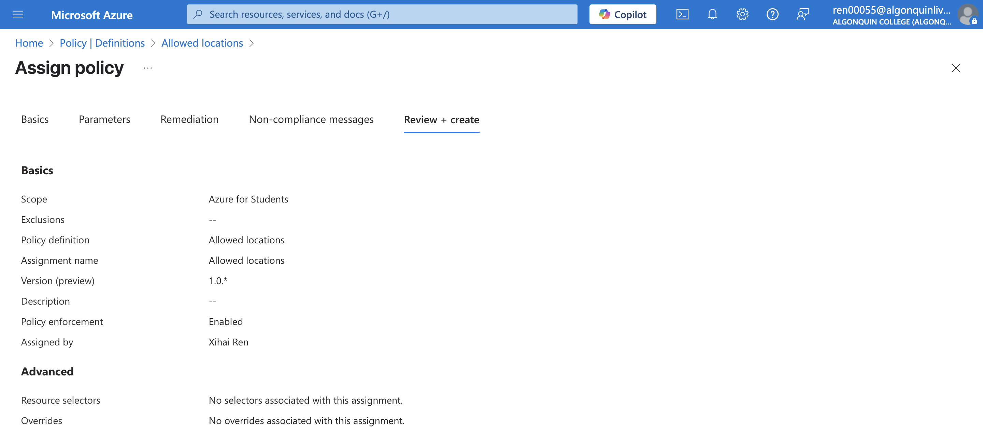

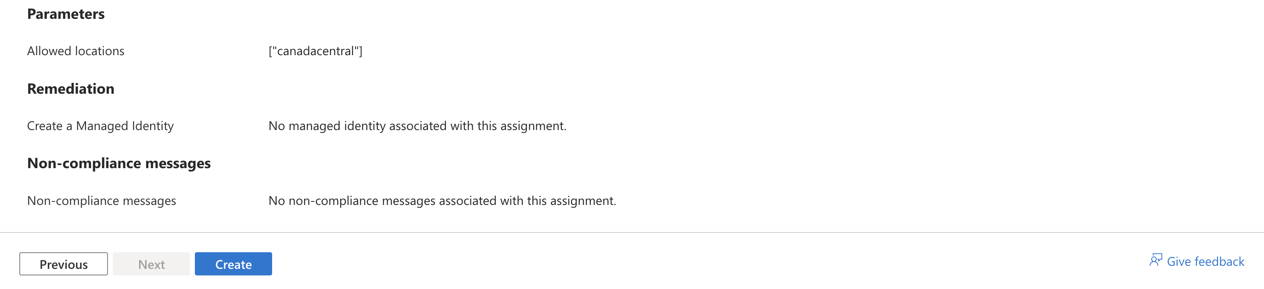

1. Test to ensure resources are only created in the Allowed location

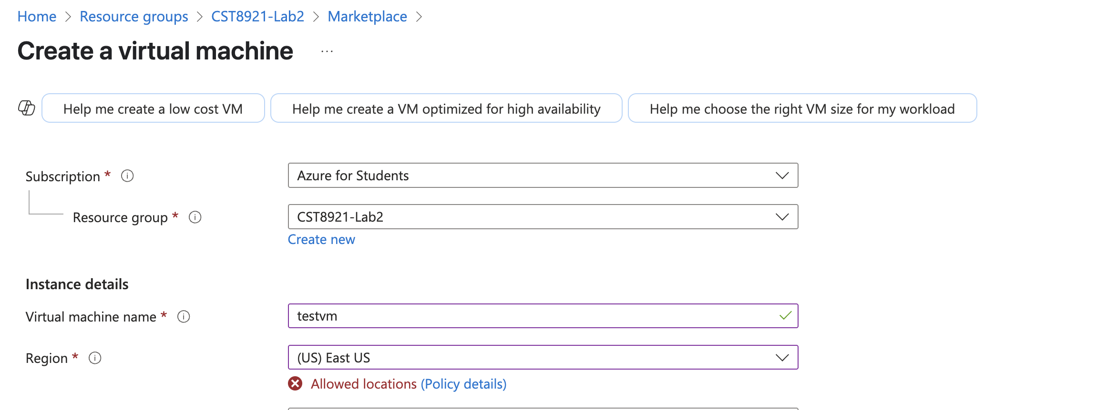

# **Service Endpoints and Securing Storage**

1. Create a storage endpoint so traffic destined to cloud storage always stays within the cloud backbone network.

Task 1: Create a virtual network in Canada Central region

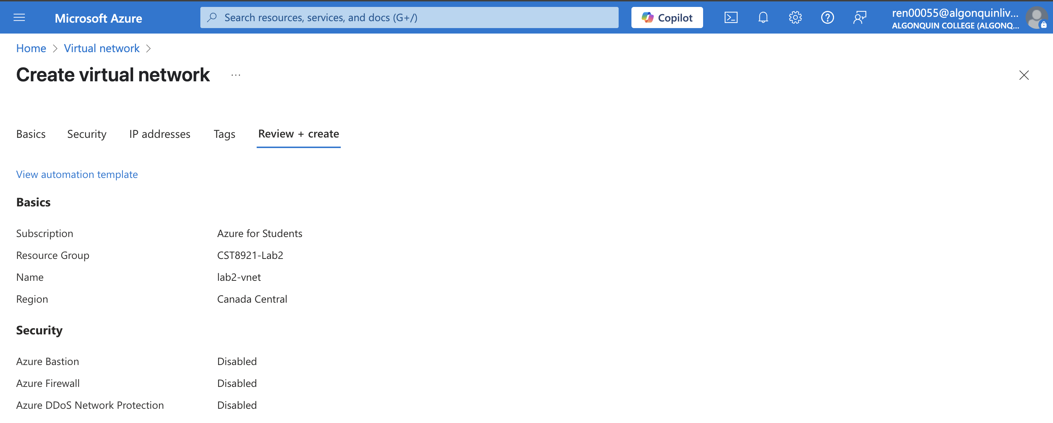

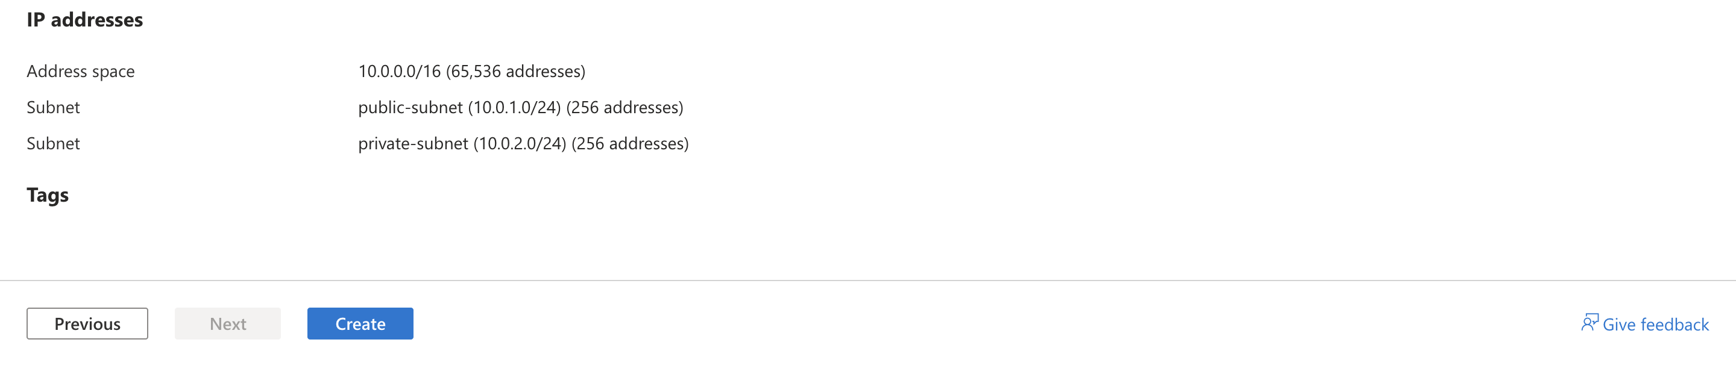

Task 2: Add a subnet to the virtual network and configure a storage endpoint

* Enable service endpoint – Create a subnet and enable a service endpoint for the subnet.
* Choose Microsoft. Storage as a service endpoint
* You should have two subnets configured.

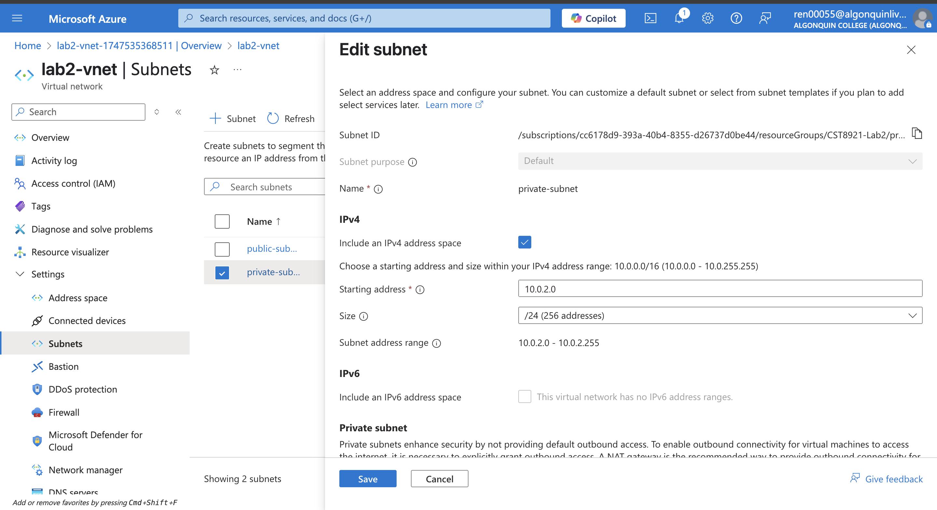

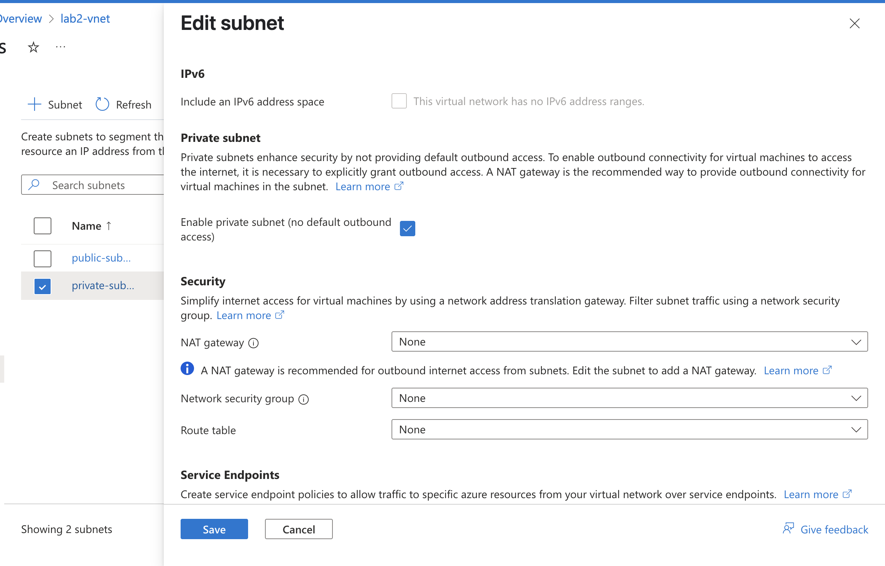

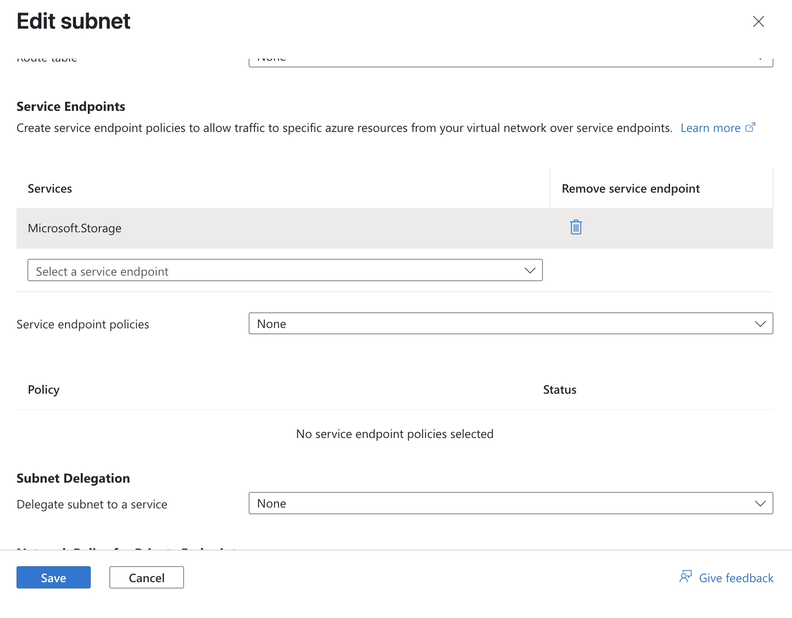

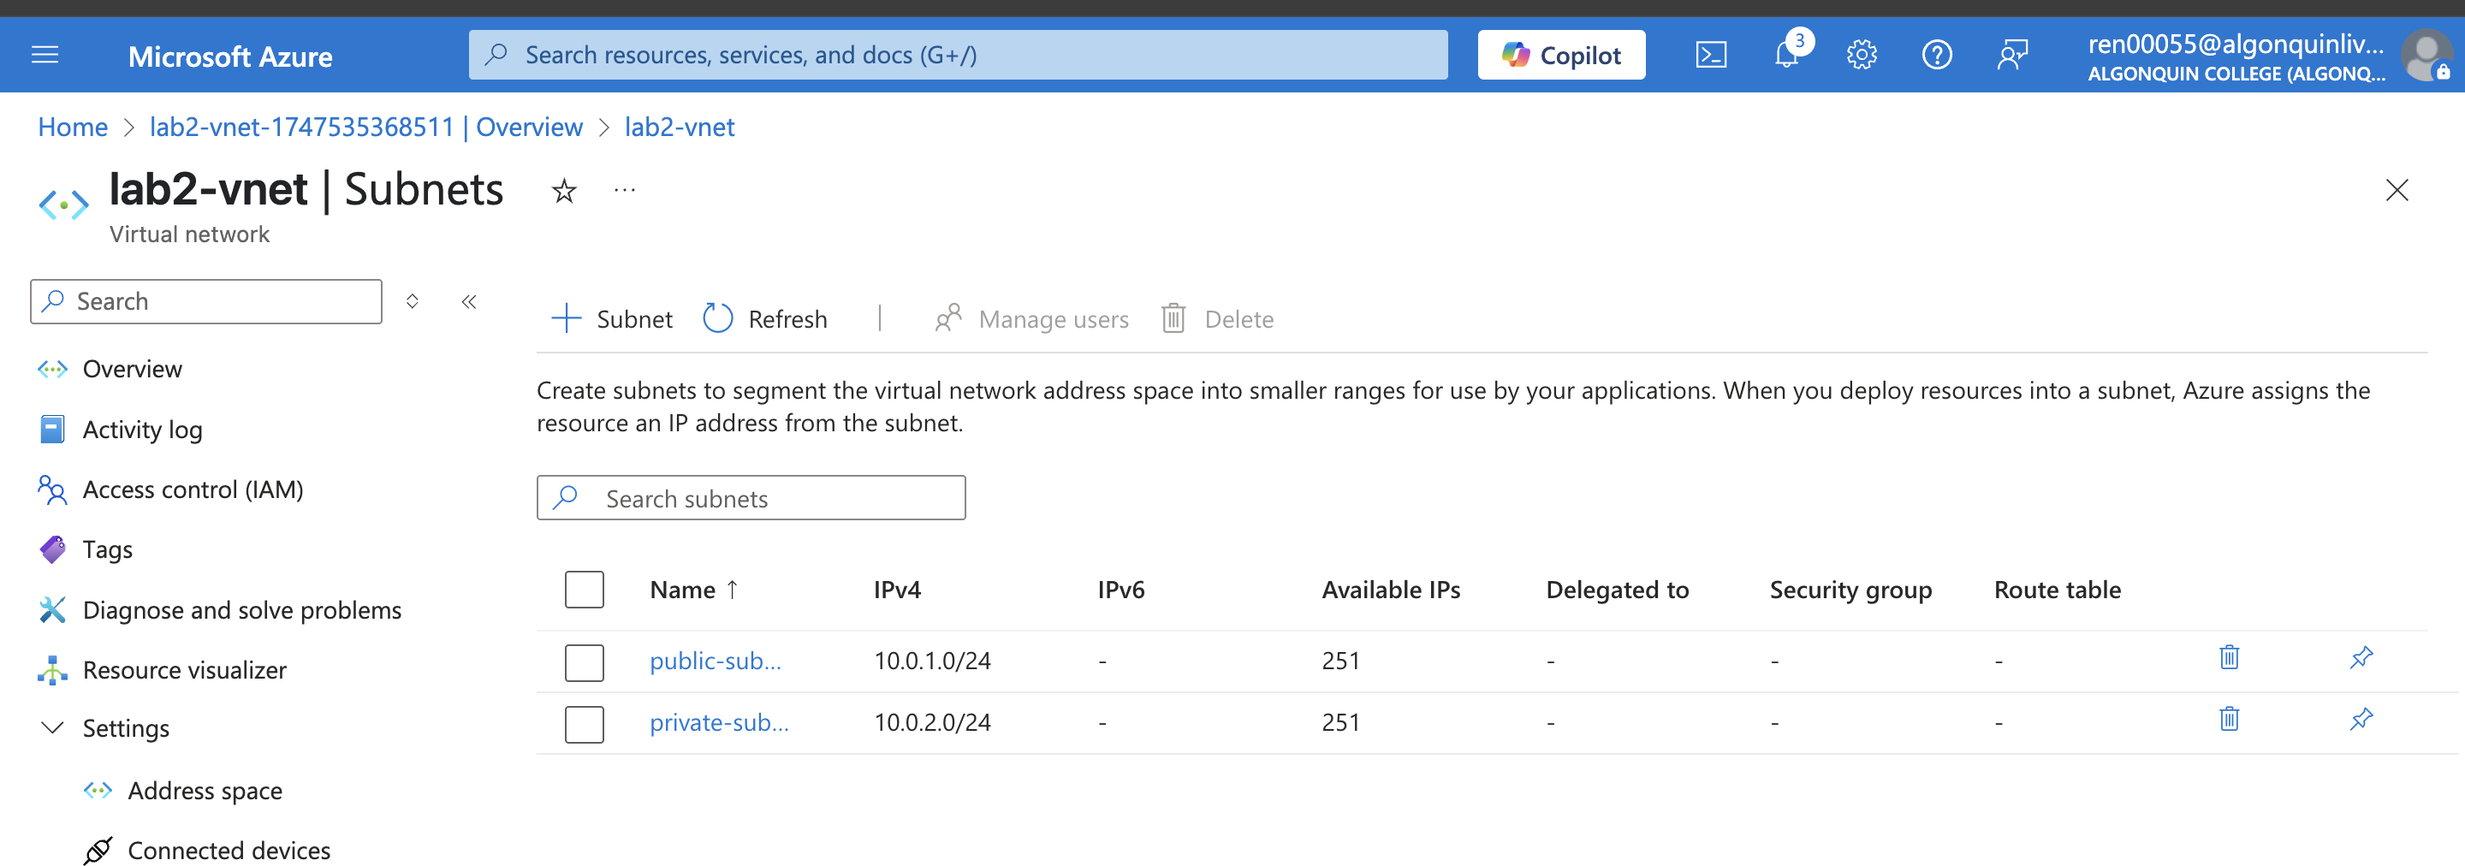

Task 3: Configure a network security group to restrict access to the subnet

* By default, all VMs in a subnet can communicate with all resources. You can limit communication to and from all resources in a subnet by creating a network security group and associating it to the subnet.
* Create NSG in Canada Central Region
* Create a rule that allows outbound communication to the Azure Storage service

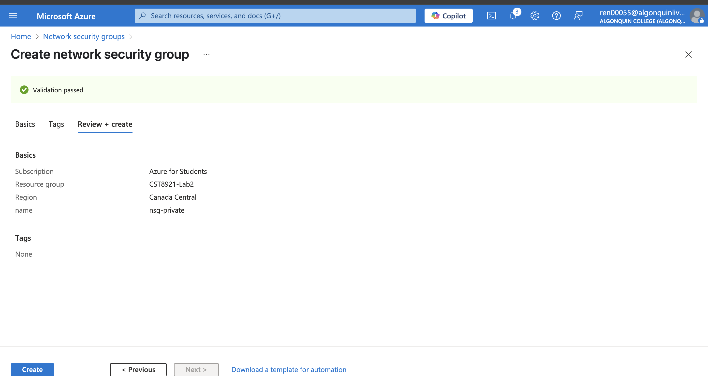

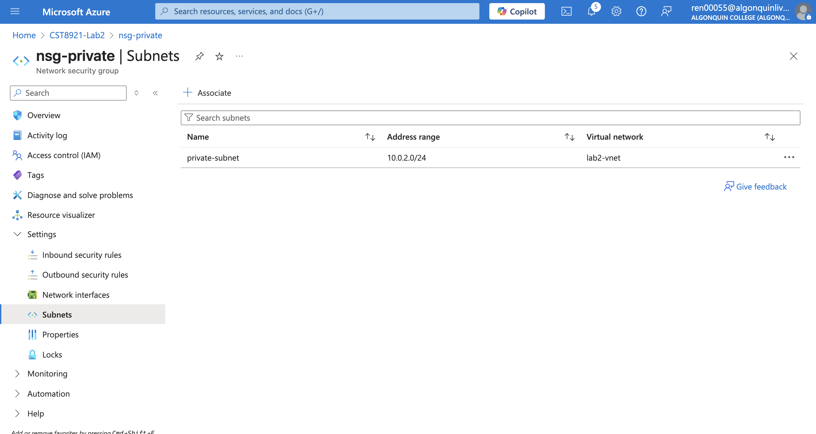

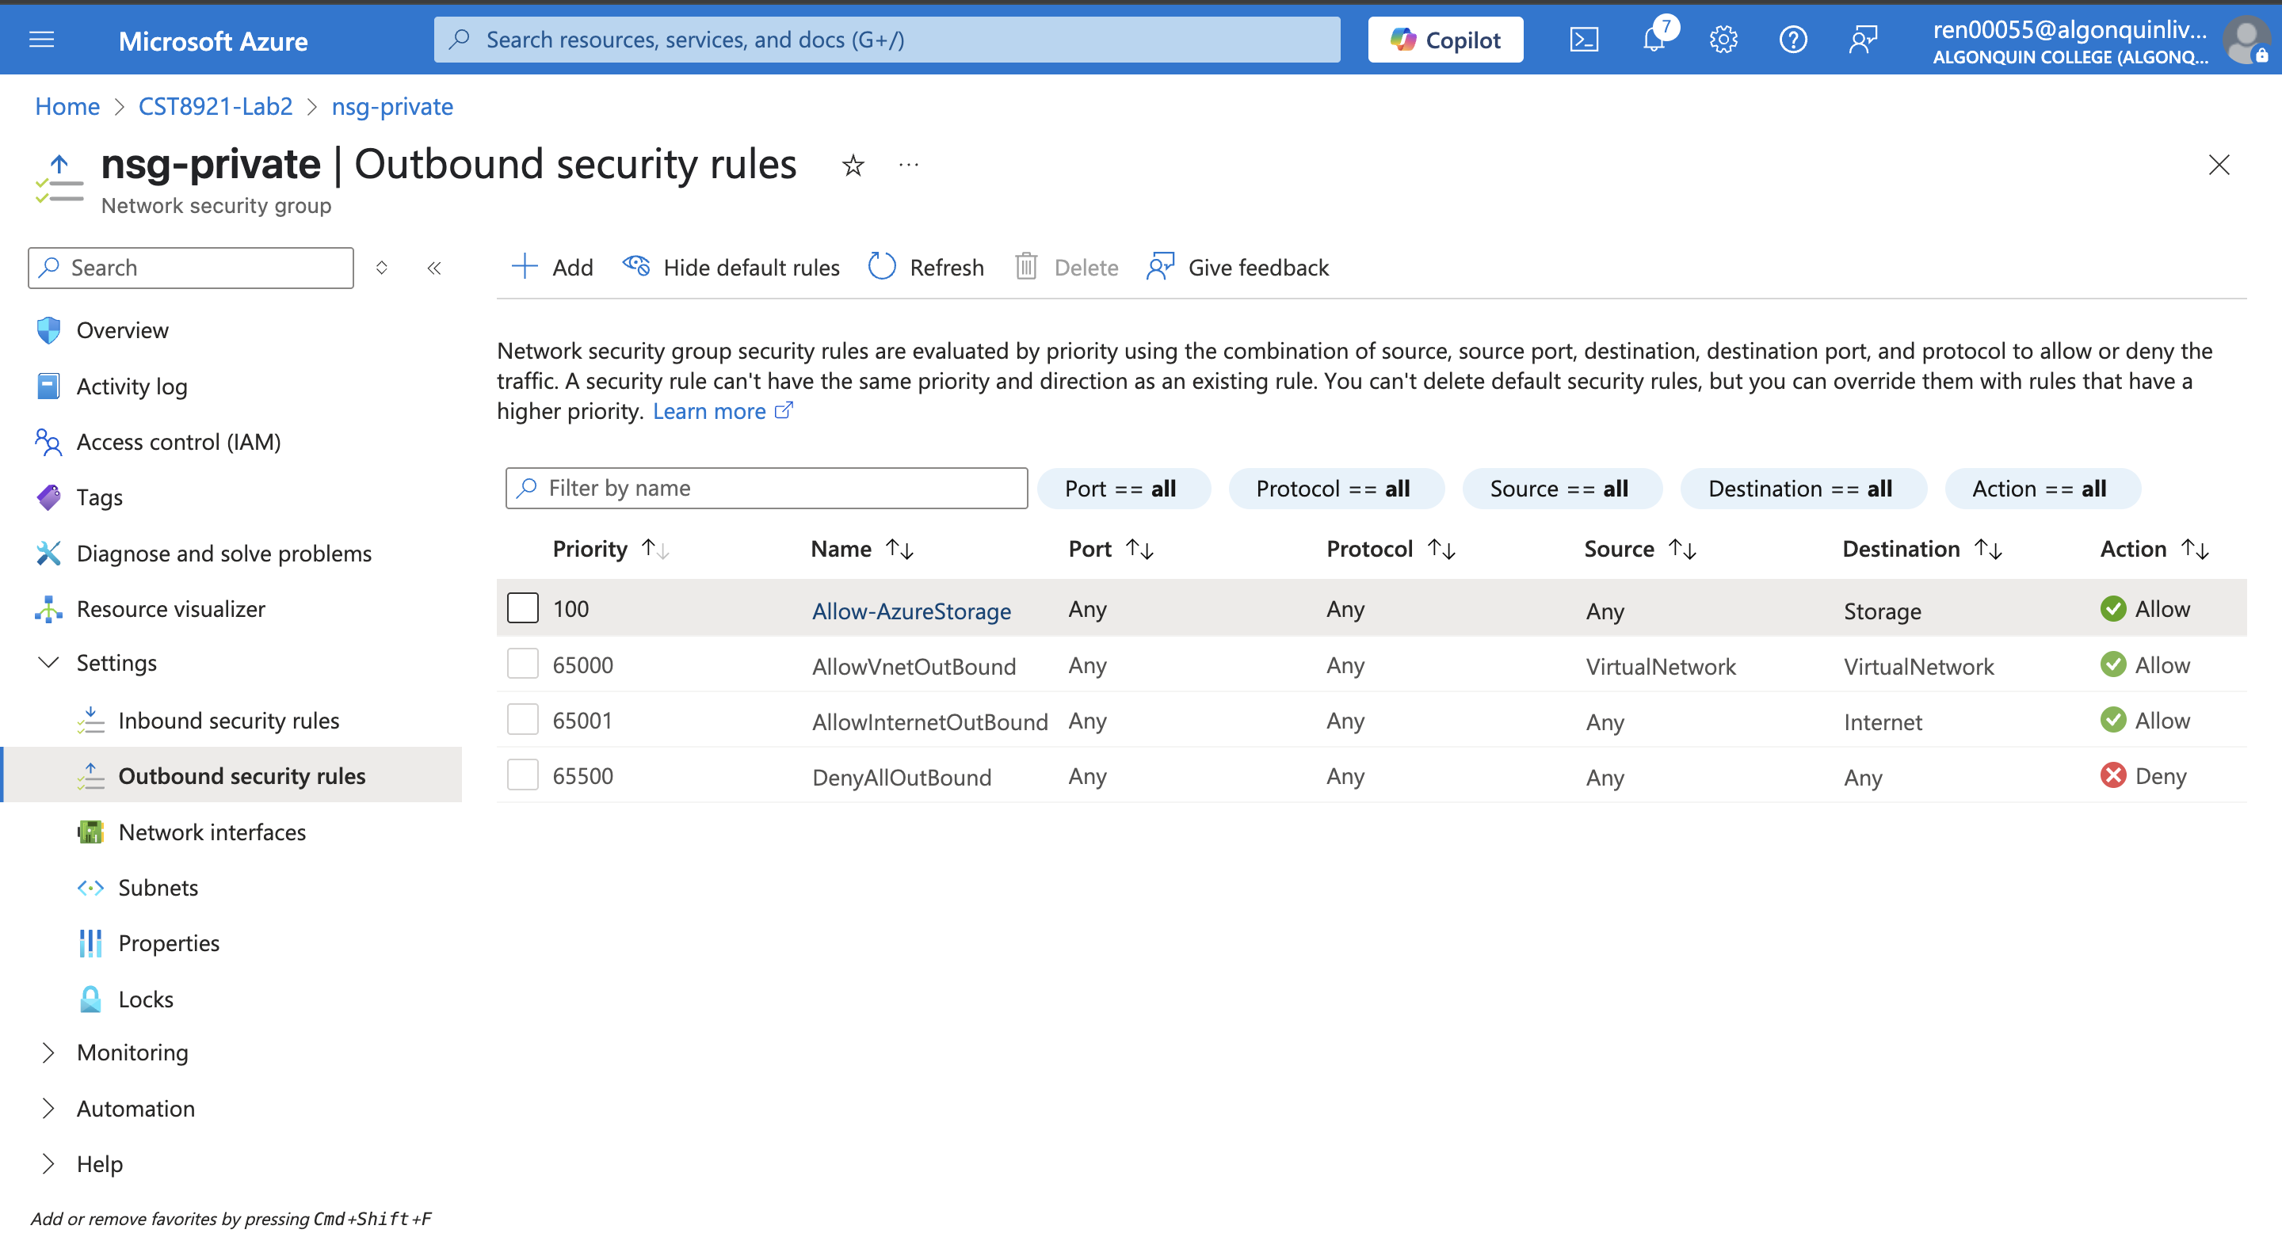

Task 4: Configure a network security group to allow rdp on the public subnet

* Create another outbound security rule that denies communication to the internet. This rule overrides a default rule in all network security groups that allows outbound internet communication.
* Create an inbound security rule that allows Remote Desktop Protocol (RDP) traffic to the subnet from anywhere. The rule overrides a default security rule that denies all inbound traffic from the internet.

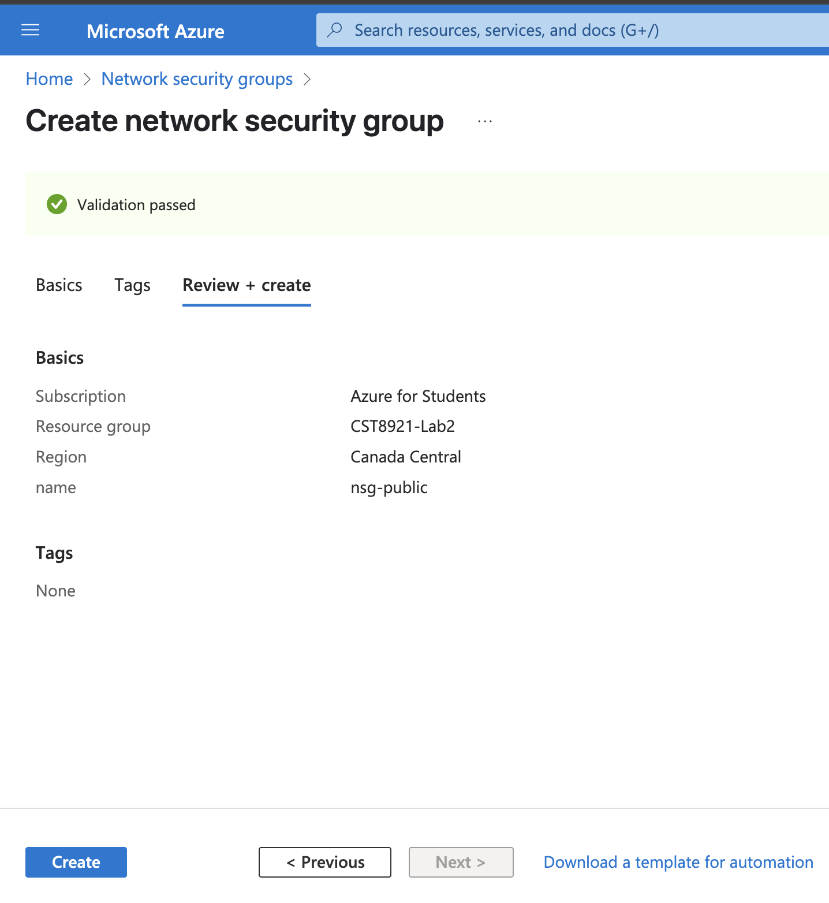

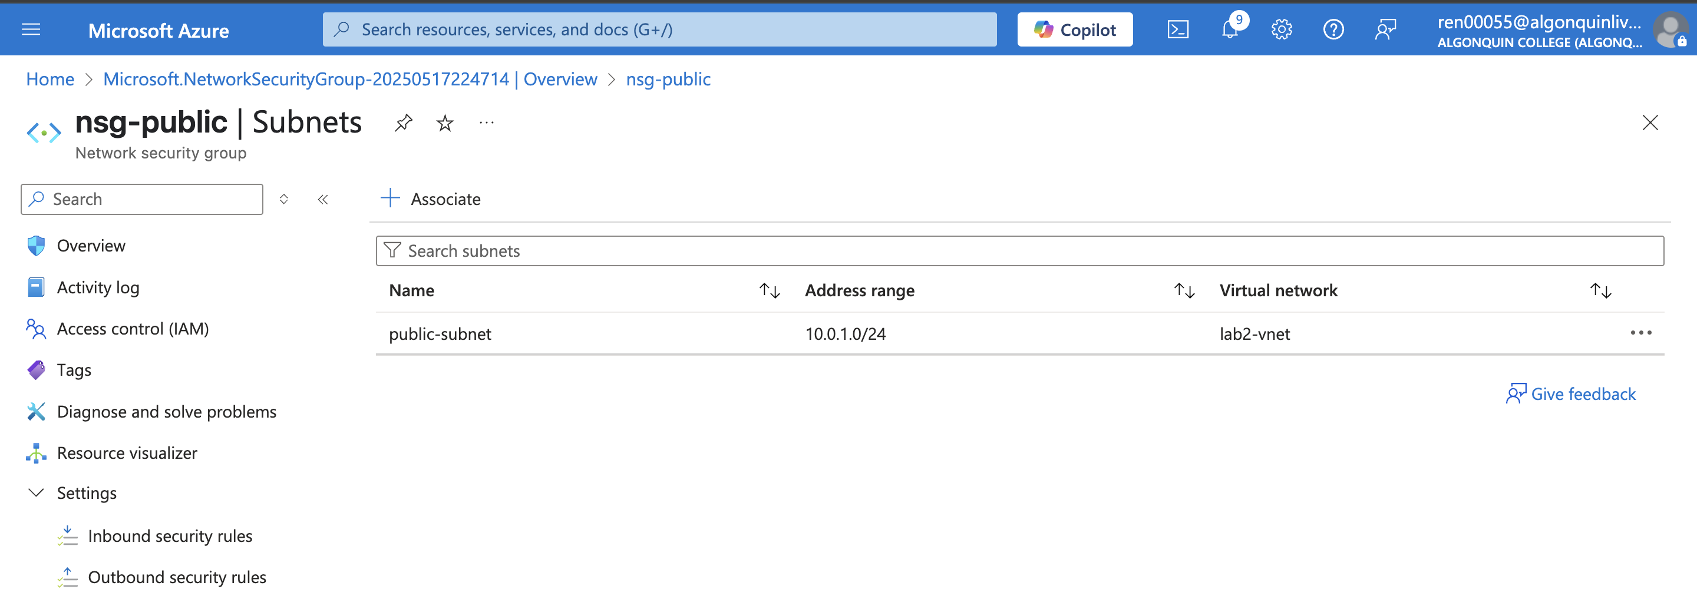

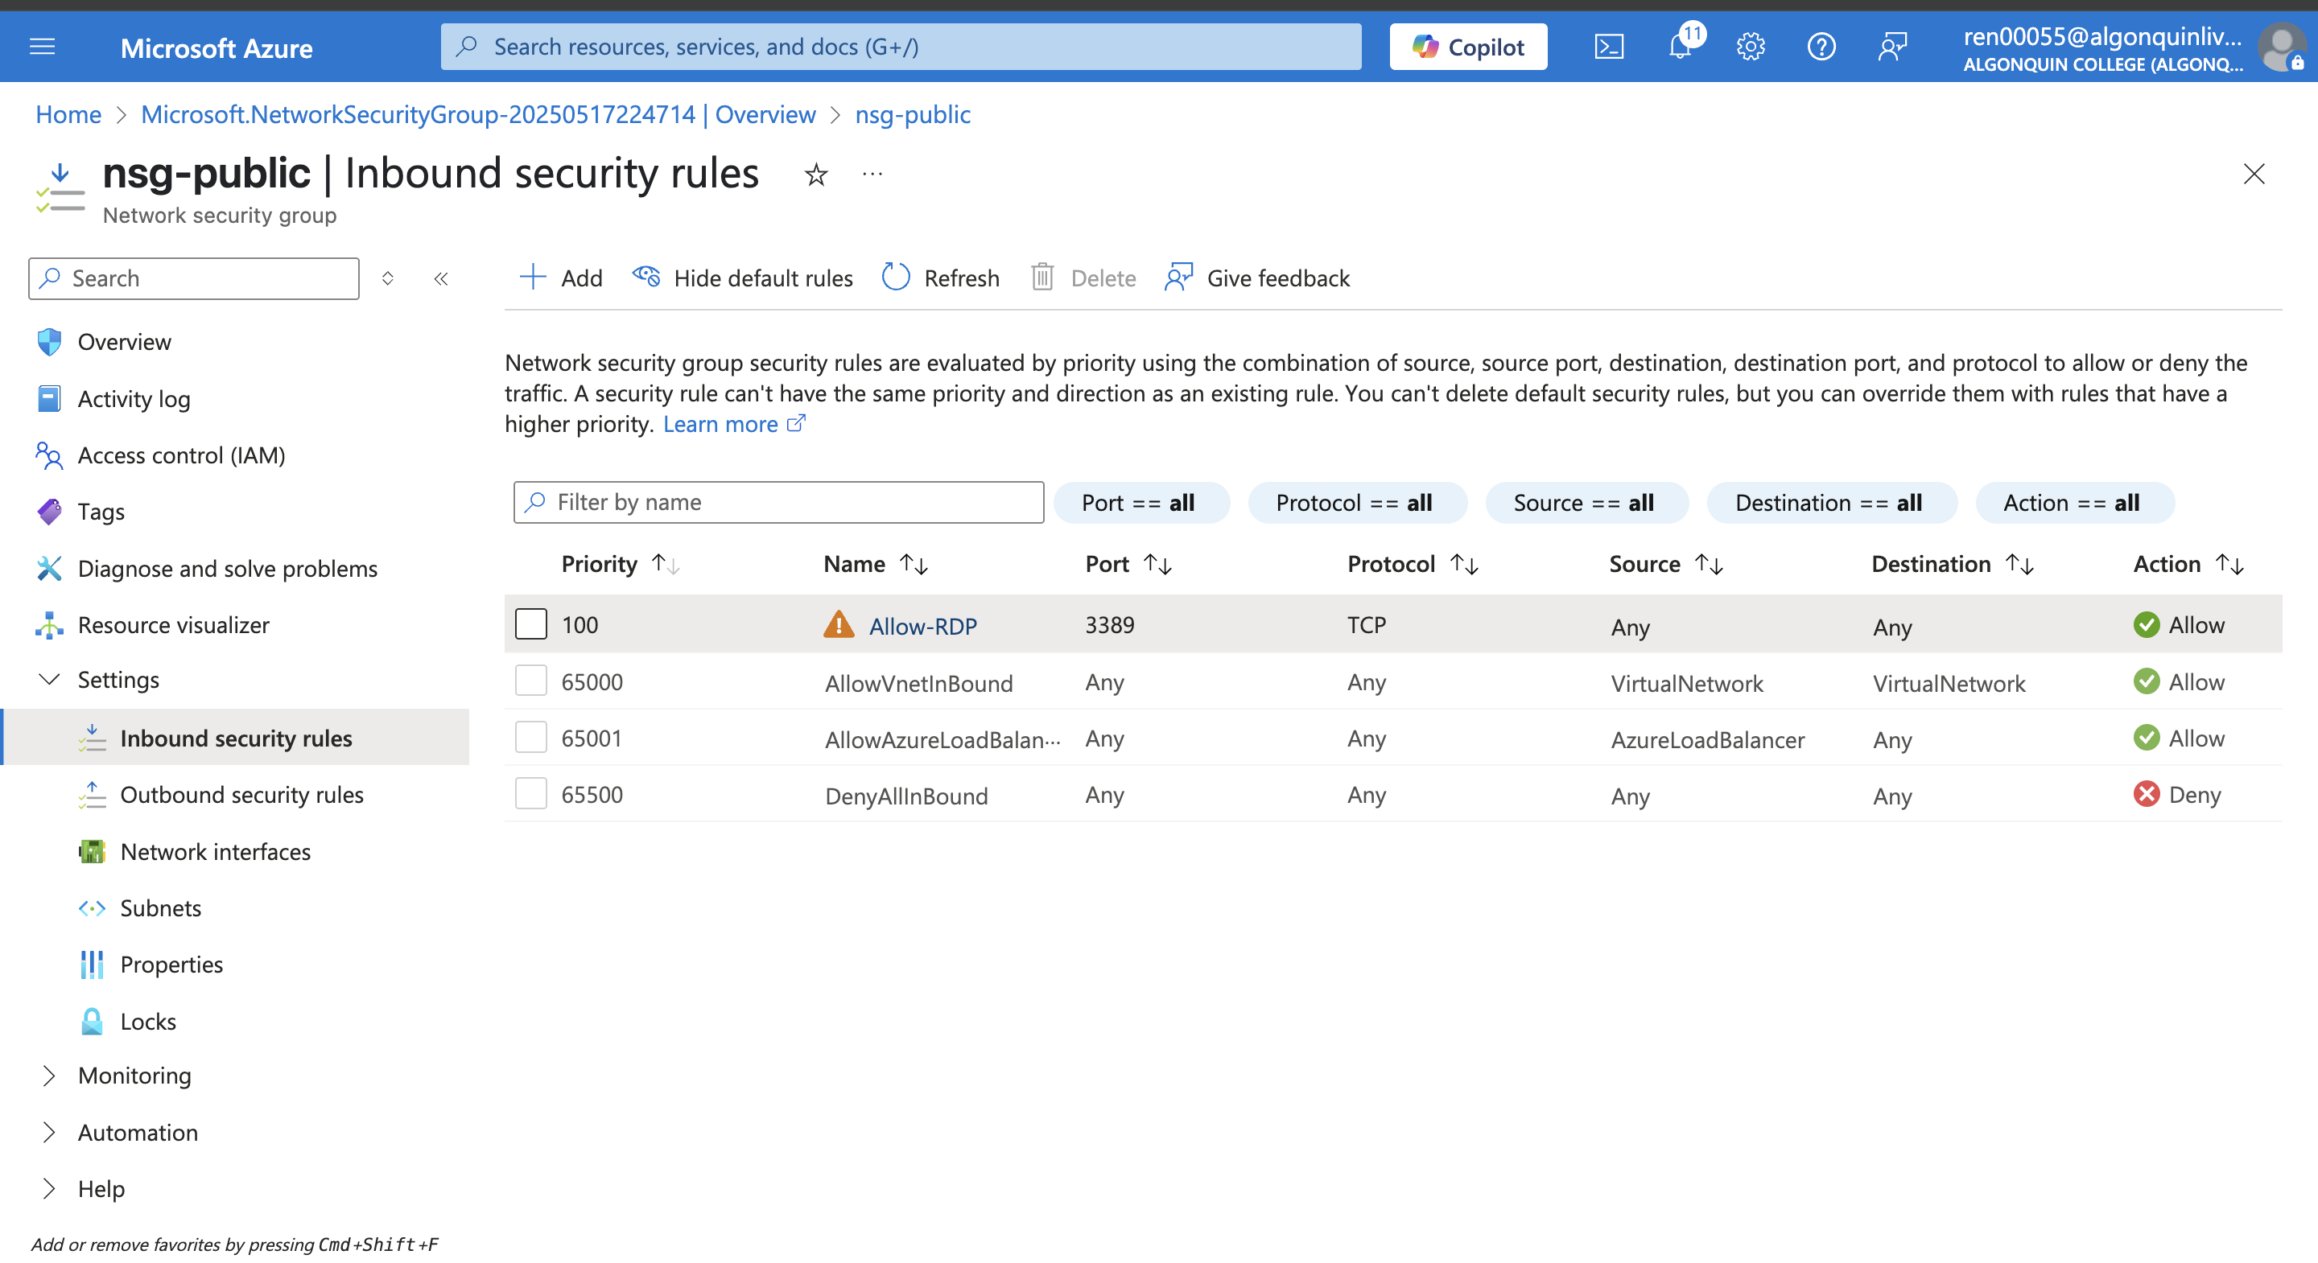

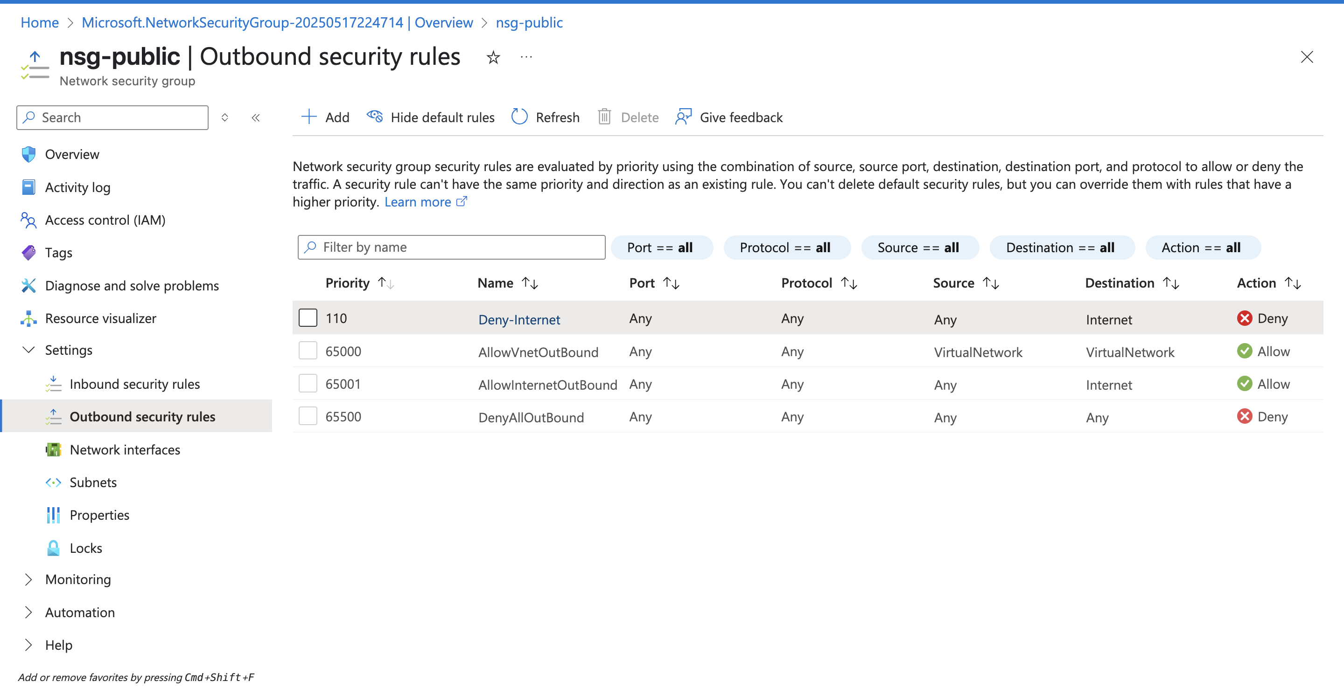

Task 5: Create a storage account with a file share

* By default, storage accounts accept network connections from clients in any network, including the internet. Deny network access from the internet, and all other subnets in all virtual networks, except for the Private subnet in the virtual network.

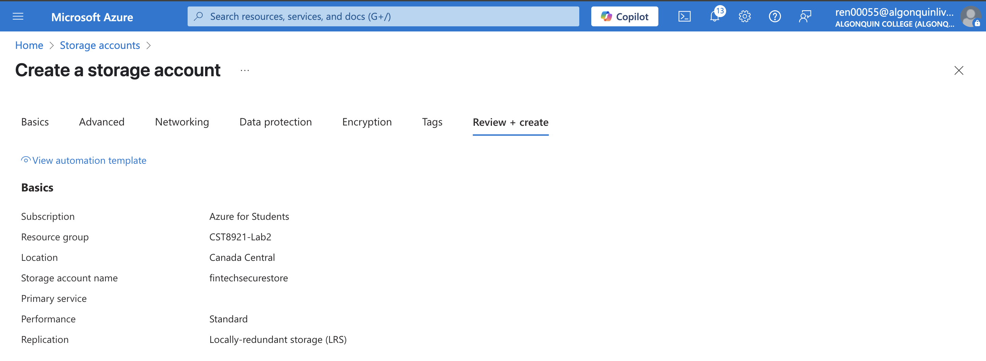

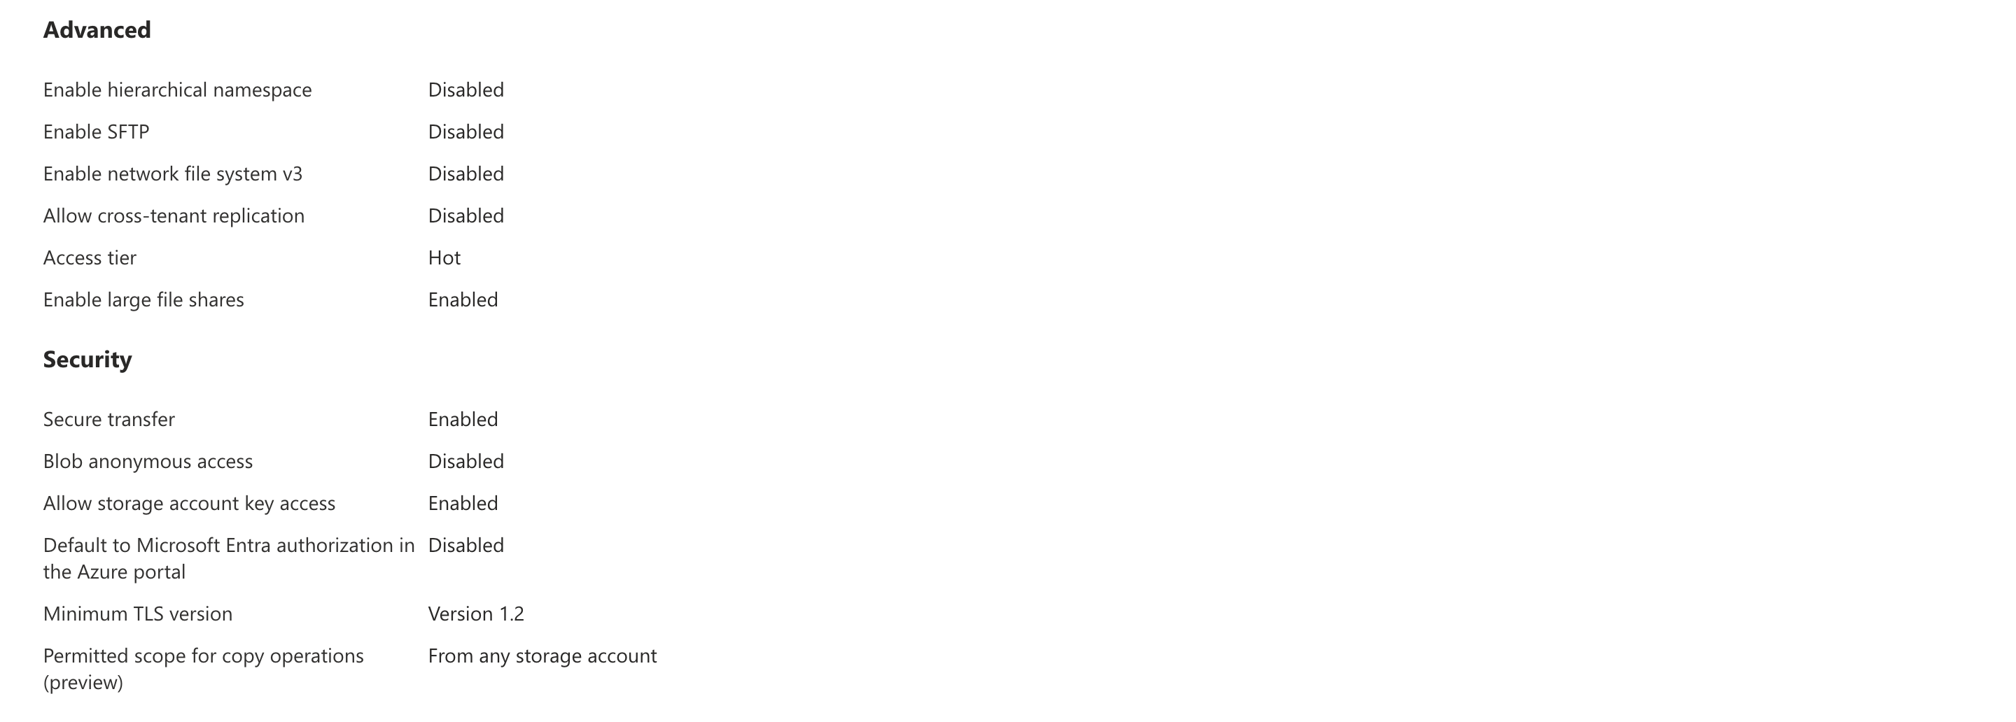

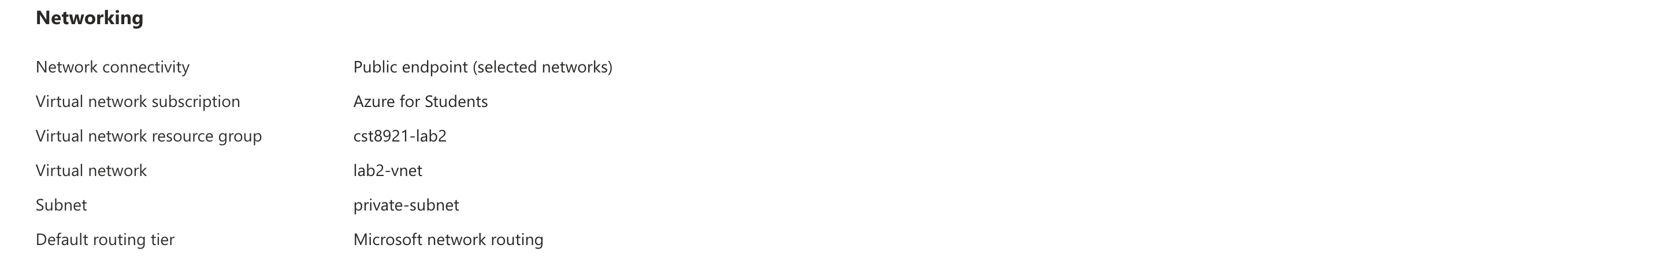

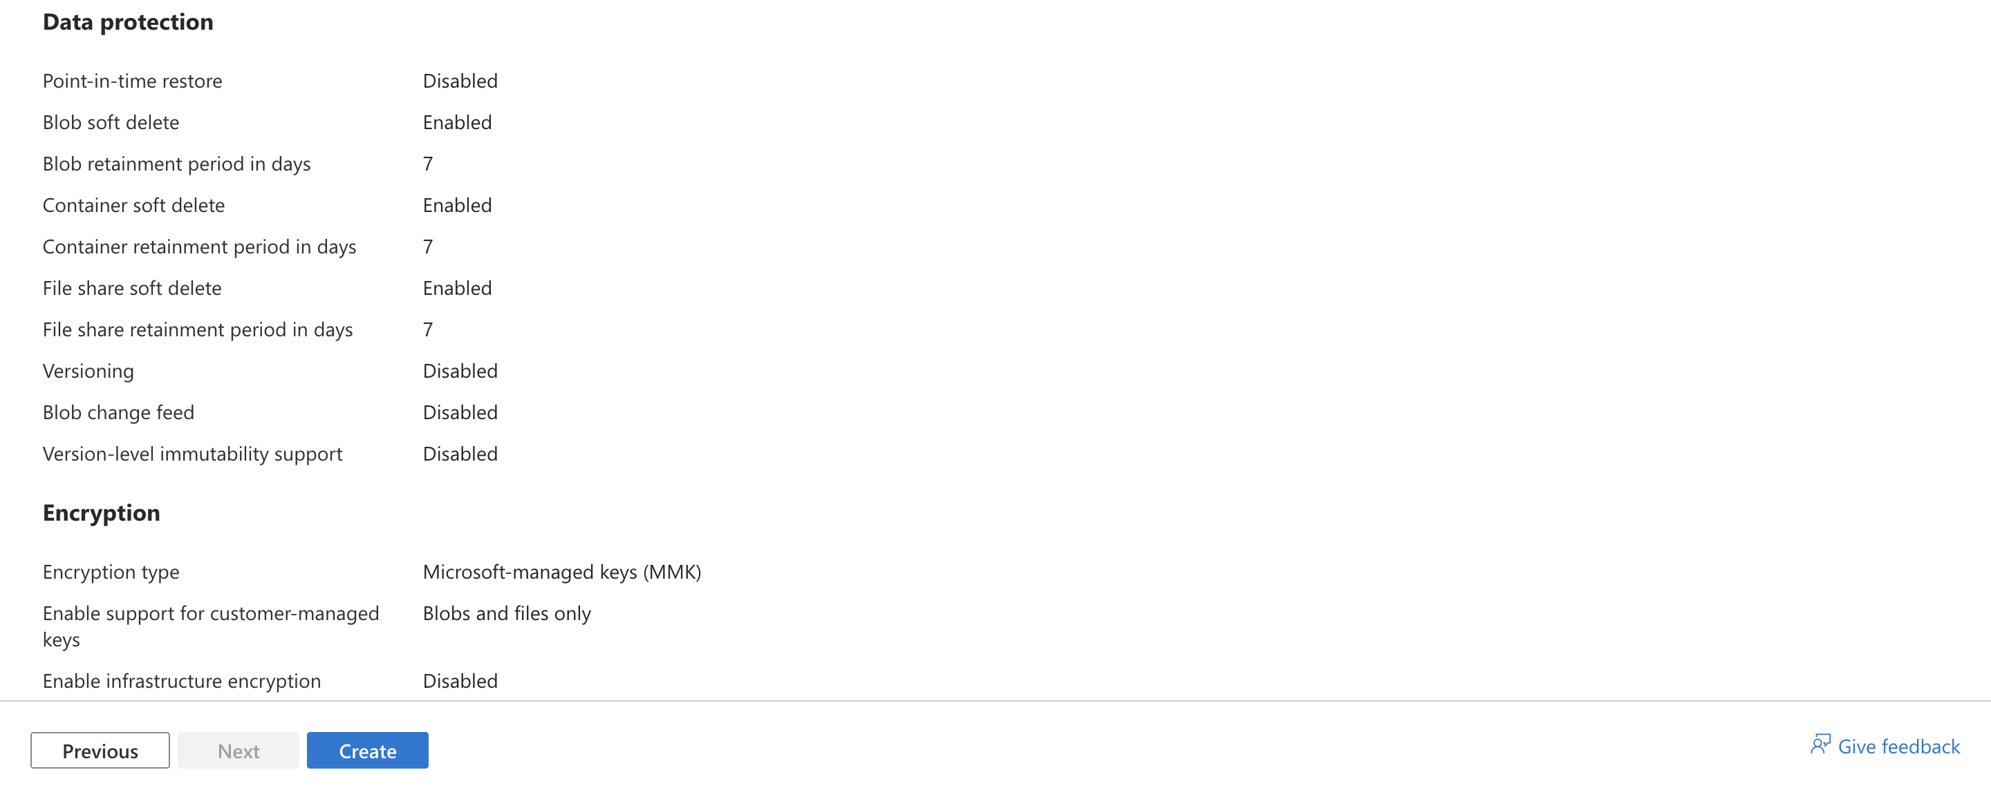

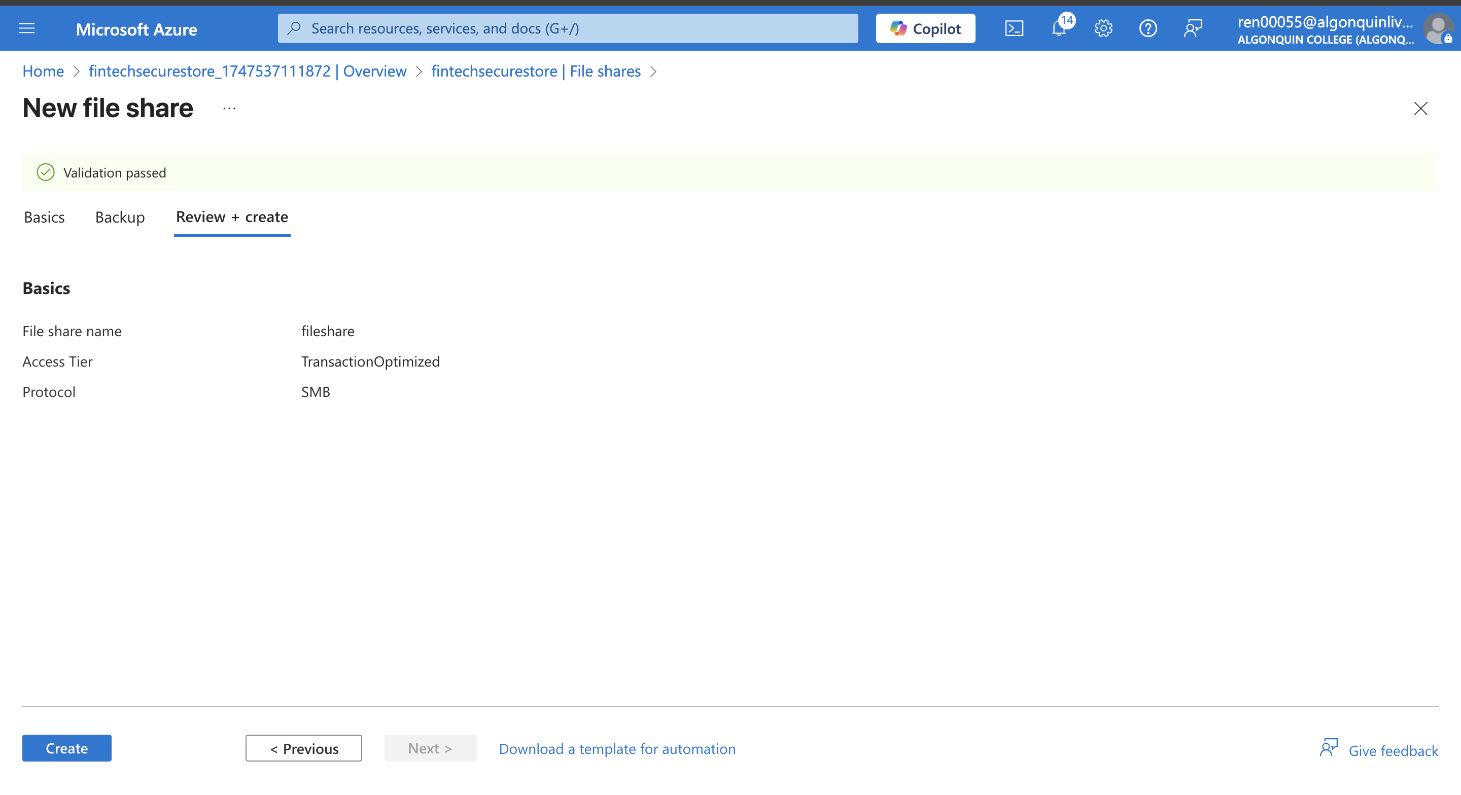

Task 6: Deploy virtual machines into the designated subnets

* To test network access to a storage account, deploy a virtual machine to each subnet

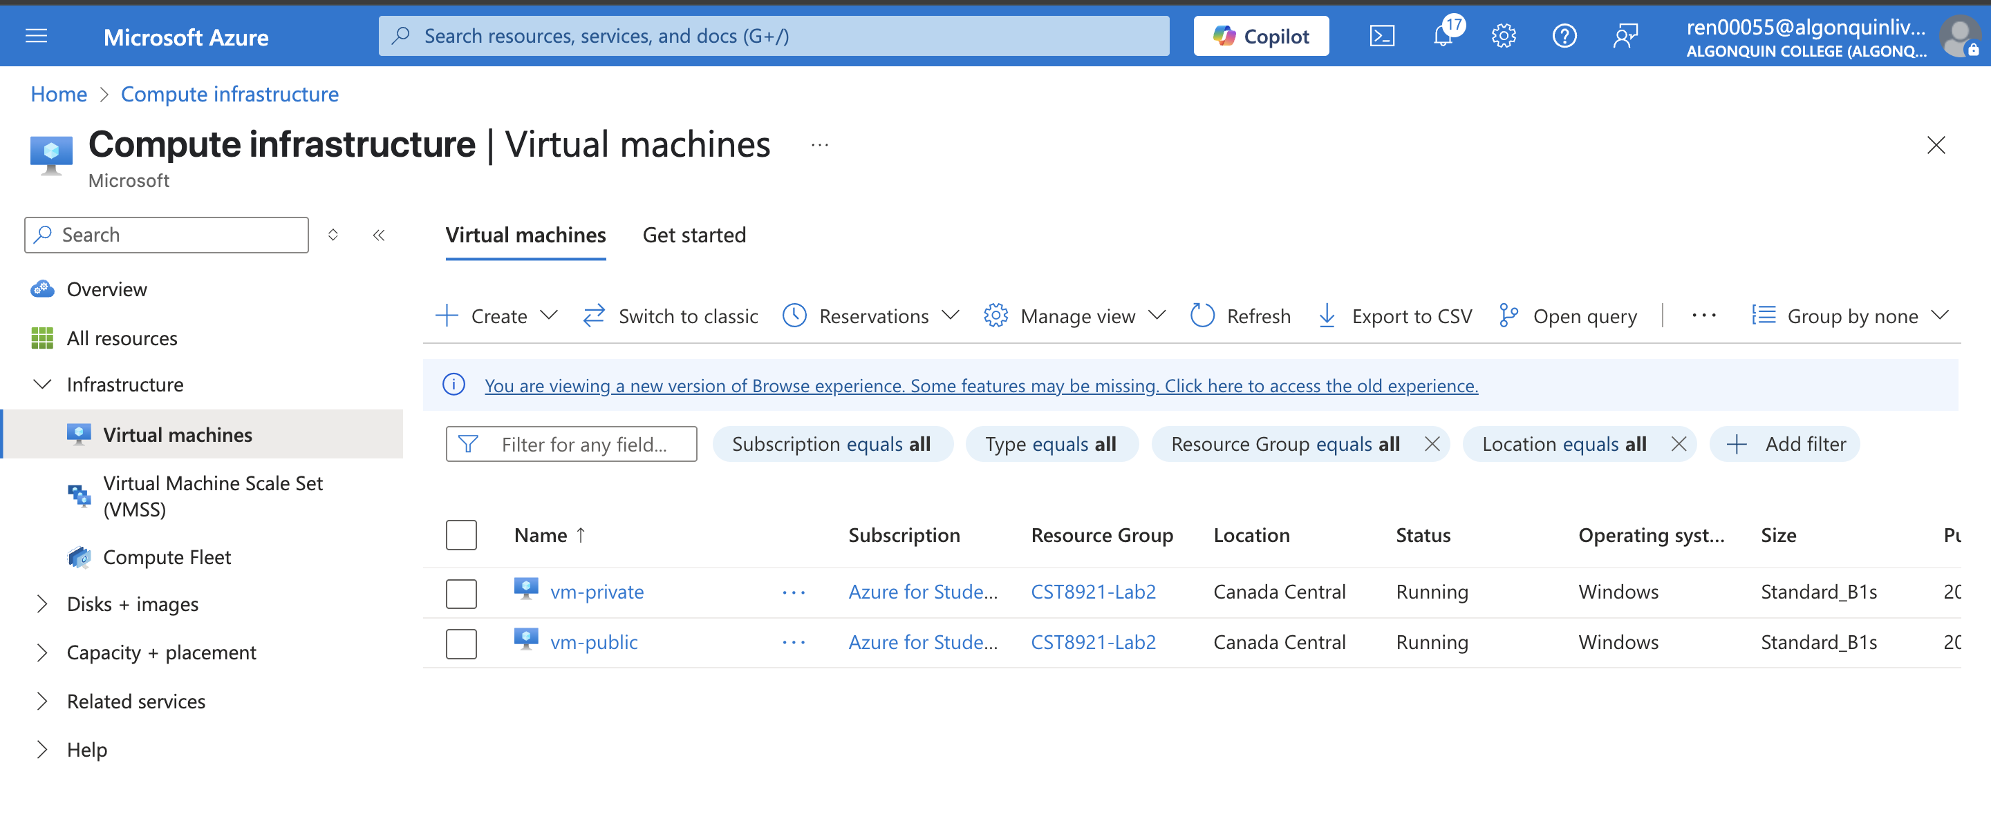

Task 7: Test the storage connection from the private subnet to confirm that access is allowed

* Get storage account access key

YeoQYhL2RDwrtPRrhQTYHRdyxEOekqJmyhgxMkR8LzlMBs0ZfrihlEWK86eeFhzFW9pGearjpkIb+AStlXCnUw==

DefaultEndpointsProtocol=https;AccountName=fintechsecurestore;AccountKey=YeoQYhL2RDwrtPRrhQTYHRdyxEOekqJmyhgxMkR8LzlMBs0ZfrihlEWK86eeFhzFW9pGearjpkIb+AStlXCnUw==;EndpointSuffix=core.windows.net

* In the search box at the top of the portal, enter Virtual machine. Select Virtual machines in the search results.
* Select vm-private.
* 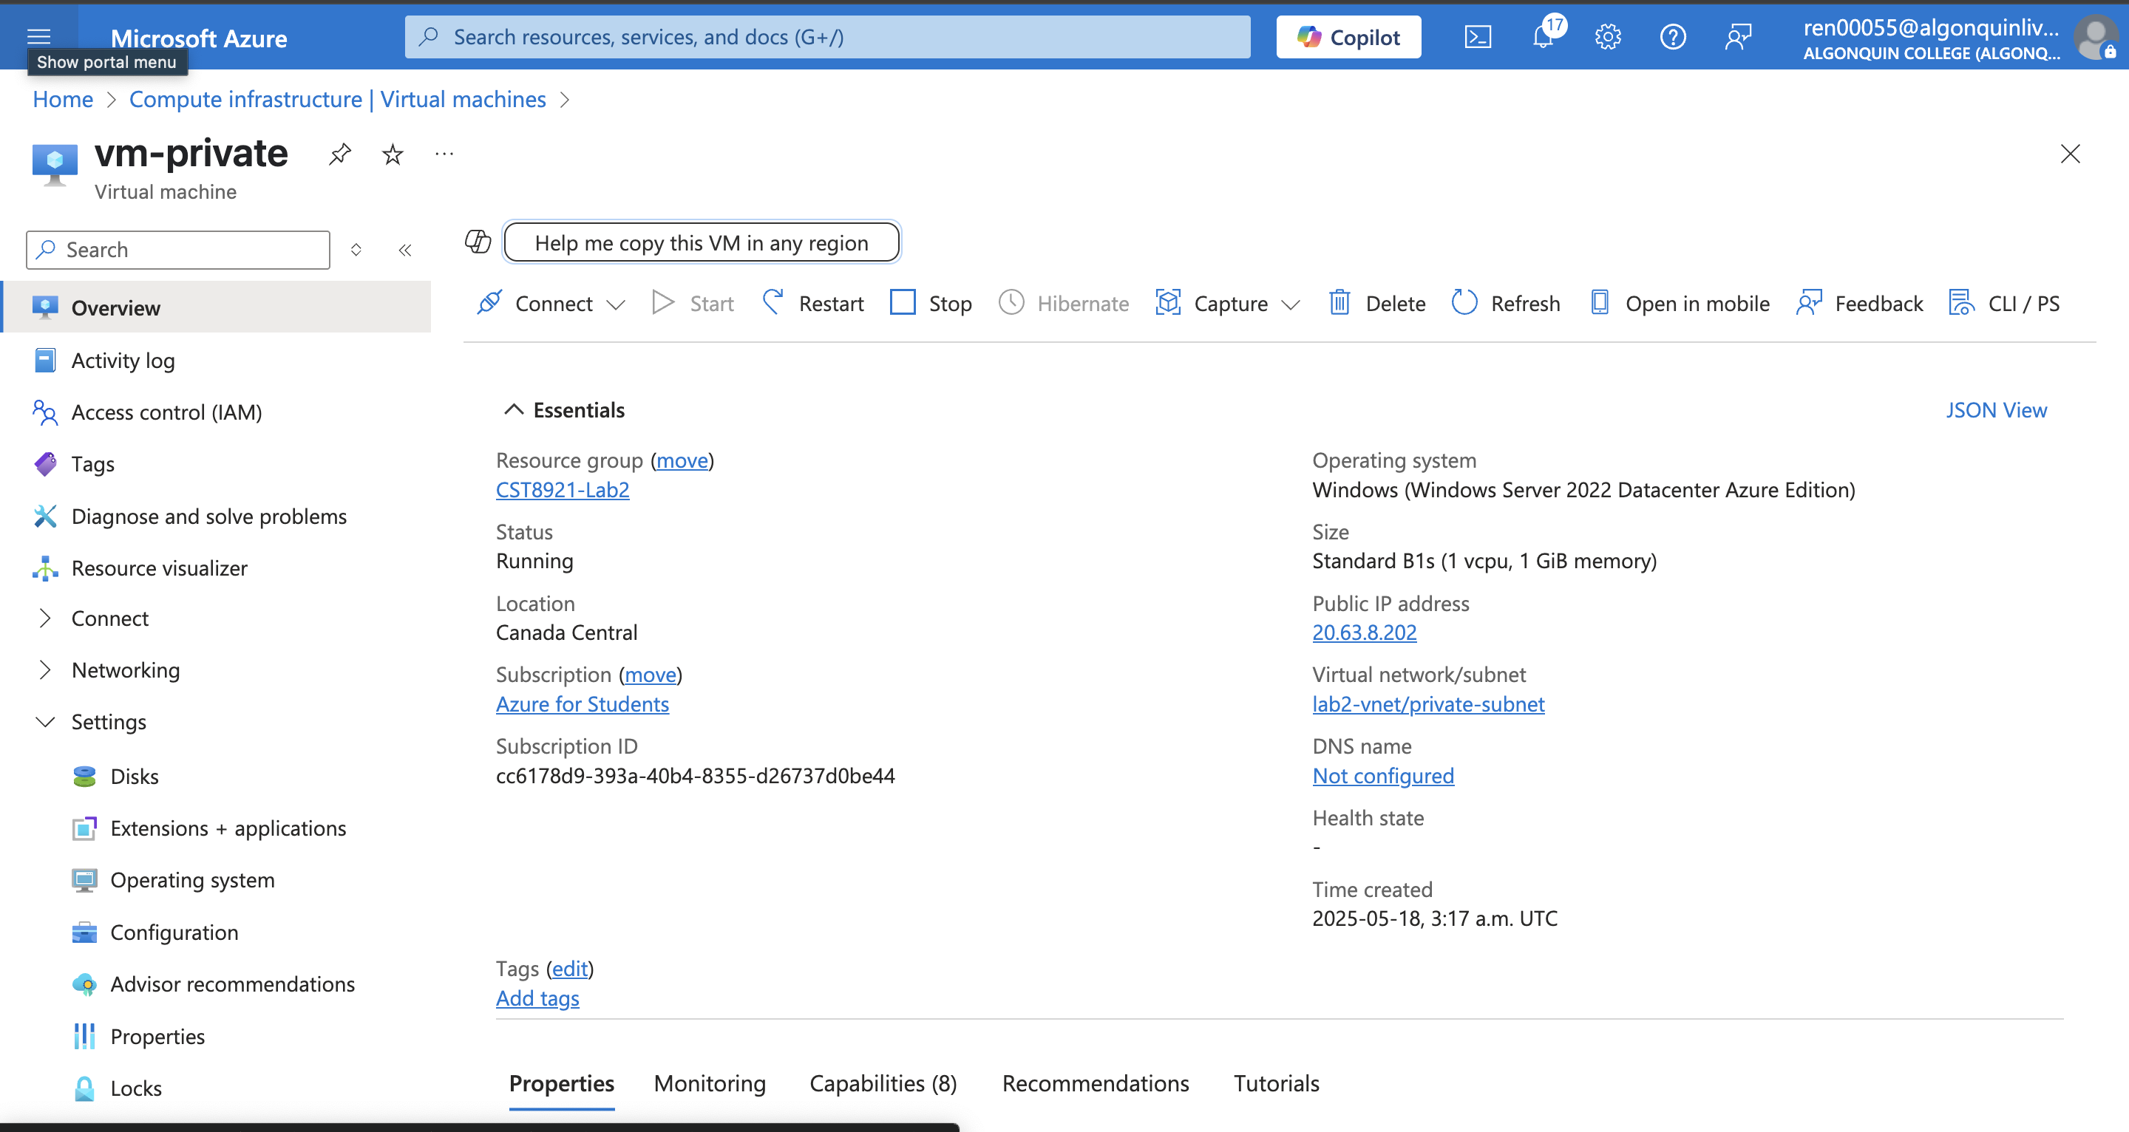
* Select Bastion in Operations.
* Enter the username and password you specified when creating the virtual machine and connect with VM
* 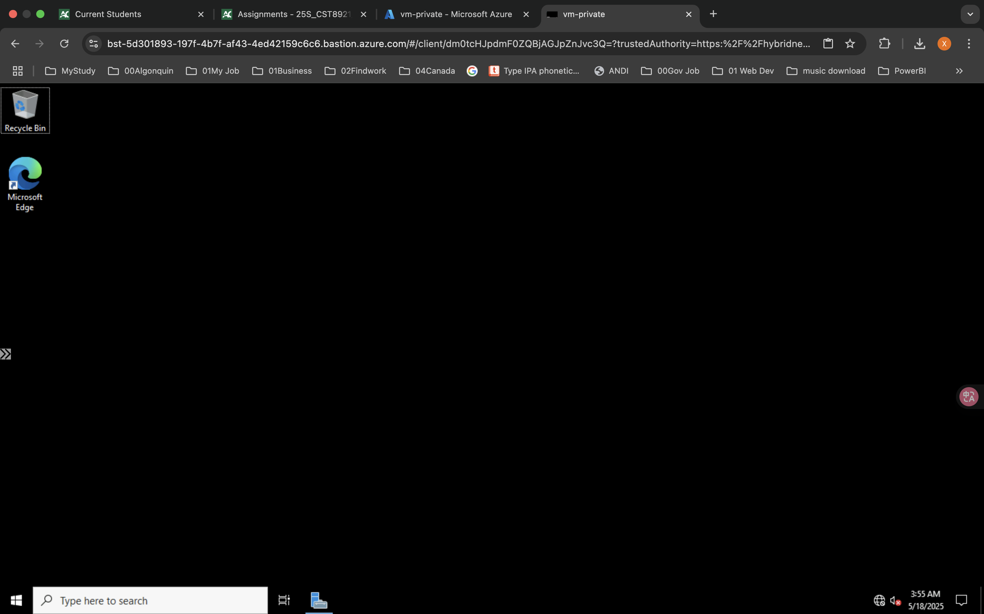
* Open Windows PowerShell to map the Azure file share to drive Z.
* Replace <storage-account-key> with the key you copied in the previous step.
* Replace <storage-account-name> with the name of your storage account

$key = @{

String = " YeoQYhL2RDwrtPRrhQTYHRdyxEOekqJmyhgxMkR8LzlMBs0ZfrihlEWK86eeFhzFW9pGearjpkIb+AStlXCnUw=="

}

$acctKey = ConvertTo-SecureString @key -AsPlainText -Force

$cred = @{

ArgumentList = "Azure\<storage-account-name>", $acctKey

}

$credential = New-Object System.Management.Automation.PSCredential @cred

$map = @{

Name = "Z"

PSProvider = "FileSystem"

Root = "\\<storage-account-name>.file.core.windows.net\file-share"

Credential = $credential

}

New-PSDrive @map

Note : The Azure file share successfully mapped to the Z drive

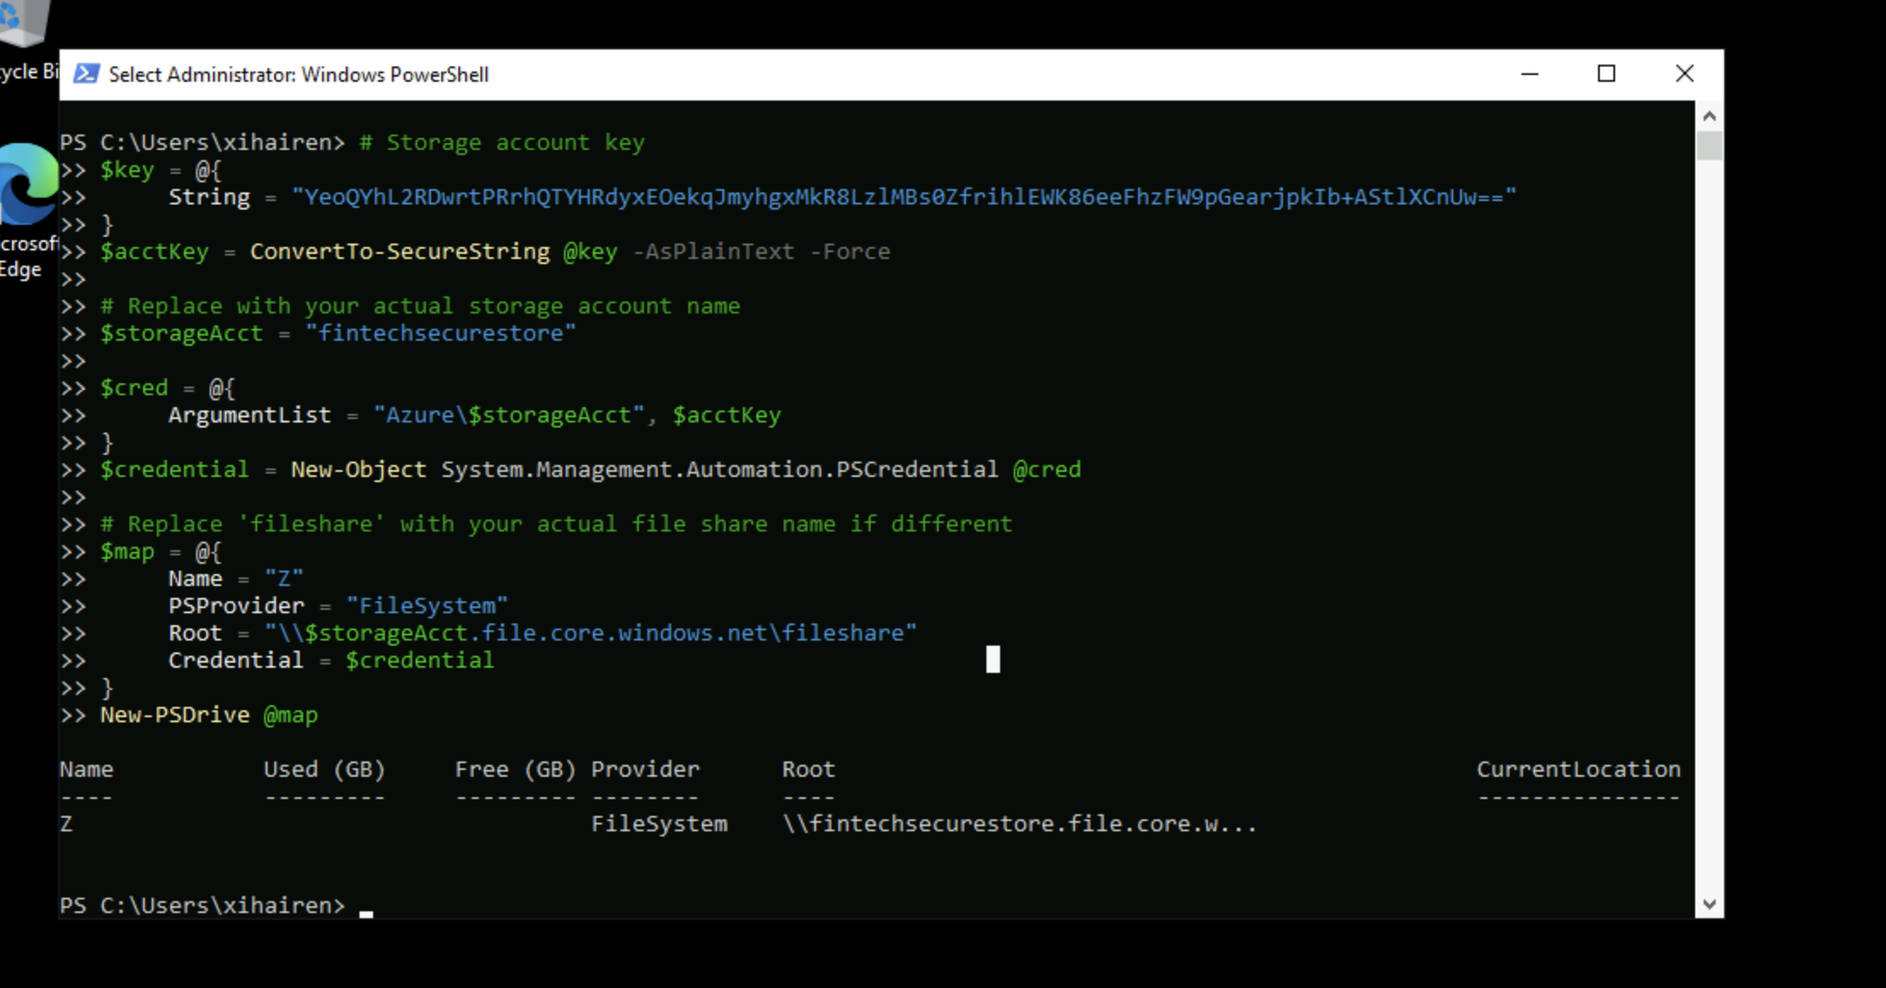

Task 8: Test the storage connection from the public subnet to confirm that access is denied

* In the search box at the top of the portal, enter Virtual machine. Select Virtual machines in the search results.
* Select vm-public.
* Select Bastion in Operations.
* Enter the username and password you specified when creating the virtual machine. Select Connect.
* Repeat the previous command to attempt to map the drive to the file share in the storage account. You may need to copy the storage account access key again for this procedure:

$key = @{

String = "<storage-account-key>"

}

$acctKey = ConvertTo-SecureString @key -AsPlainText -Force

$cred = @{

ArgumentList = "Azure\<storage-account-name>", $acctKey

}

$credential = New-Object System.Management.Automation.PSCredential @cred

$map = @{

Name = "Z"

PSProvider = "FileSystem"

Root = "\\<storage-account-name>.file.core.windows.net\file-share"

Credential = $credential

}

New-PSDrive @map

Note : You should receive an error message of access denied

1. Configure the storage endpoint so only resources from a specific subnet can access the storage.

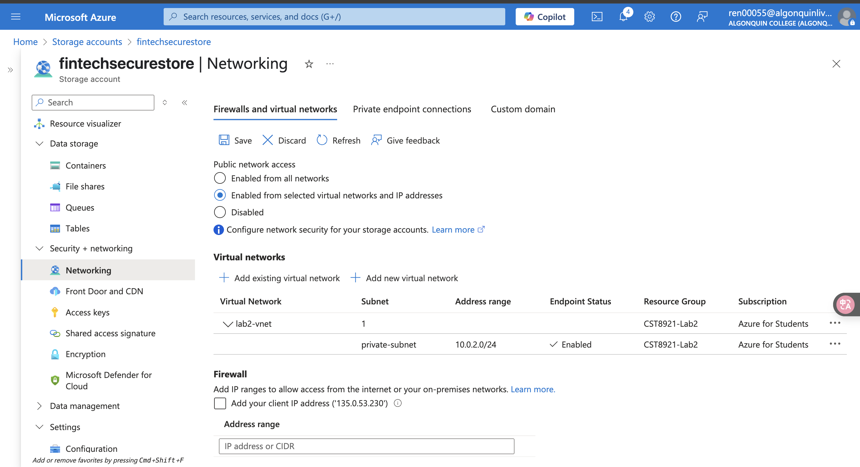

1. Confirm that resources outside of the specific subnet cannot access the storage.

